DNS CNAME Record

🔗 What is a DNS CNAME Record?
# Source: Chatgpt (GPT-5-Mini) at [1/18/2026]
A CNAME Record (Canonical Name Record) is a type of DNS record that maps one domain name (an alias) to another domain name (the canonical name).
🧠 It’s like saying:
"This domain name is just another name for that domain."

🔍 Details of CNAME Record
# Source: Chatgpt (GPT-5-Mini) at [1/18/2026]
- Purpose: To alias one domain to another, so both point to the same IP or service.
- Format:
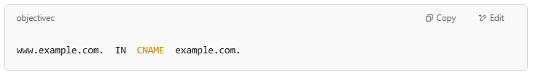
www.example.com. IN CNAME example.com.
- Effect: When you look up www.example.com, the DNS returns the canonical name example.com, which then resolves to an IP address via its A or AAAA record.

🌐 Why Use CNAME Records?
# Source: Chatgpt (GPT-5-Mini) at [1/18/2026]
- To easily manage multiple domain names that should point to the same server.
- Simplifies DNS management — update the IP on the canonical domain only.
- Commonly used for subdomains like www, mail, or ftp.

🔁 Relation with Other Records
# Source: Chatgpt (GPT-5-Mini) at [1/18/2026]
- CNAME points to another domain name, NOT directly to an IP.
- The canonical domain (the target) must have its own A or AAAA record.
- You cannot have other record types (like A, MX) on a CNAME record’s name.

Example
# Source: Chatgpt (GPT-5-Mini) at [1/18/2026]
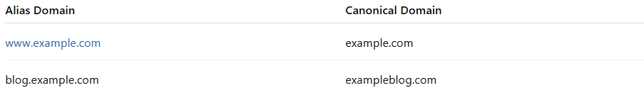
Alias Domain | Canonical Domain
www.example.com | example.com
blog.example.com | exampleblog.com

✅ Summary
# Source: Chatgpt (GPT-5-Mini) at [1/18/2026]
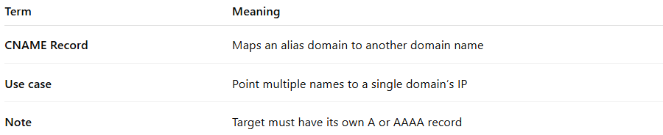

Term | Meaning
CNAME Record | Maps an alias domain to another domain name
Use case | Point multiple names to a single domain’s IP
Note | Target must have its own A or AAAA record

